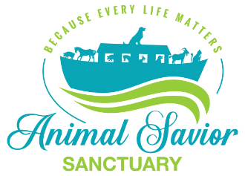

Adoption Contract

Name of Animal: Date:
Sex: Spayed/Neutered: Date (if known):
Vaccinated/Wormed:
Physical Description of animal: _______________________________________________________________________
I, ___________________________________ promise to care for this animal in a humane manner and to provide a good home and kind treatment. I promise to have it vaccinated/wormed and examined regularly and to provide routine and/or emergency health care that is recommended by a veterinarian that is knowledgeable in the specific care of this species.
I promise that this animal shall not be used for purposes of breeding, experimentation, or as a food source for humans or other animals.
If, at any time I am unable to keep this animal for any reason, I will immediately contact Animal Savior Sanctuary from which I adopted the animal.
By signing this contract, I agree that in the event there is a reason to suspect the animal is not receiving proper care, a scheduled home visit may be performed by Animal Savior Sanctuary from which I am adopting and/or designated agent to ensure the health and well-being of said animal.
I accept this animal in its *current condition and for which I will not hold any other party responsible. I hereby release Animal Savior Sanctuary from all liability of injuries or illness sustained while this animal is in my care.
By signing this contract, I agree to have this animal transported to my location in a safe and humane manner. A ______ adoption fee/donation is required upon completion of this contract. All funds went to the care of this animal and will not be refunded.
Finally, by signing this contract I understand and agree to relinquish this animal without interference if Animal Savior Sanctuary or other recognized animal control agency determines that there is evidence of inhumane or improper care.
Signed: _______________________________________ Print Name: ________________________________
Address: _________________________________________________________________________________
City: _______________________________ State: ______ Zip: ____________
Telephone: ____________________________ Email: _____________________________________________
*List known physical condition(s), if any

