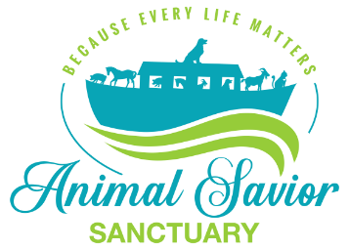

Volunteer Release of Liability

Name: ____________________________________________________________________________________
Address: ___________________________________________________________________________________
__________________________________________________________________________________________
Phones: ___________________________________________________________________________________
Email: _____________________________________________________________________________________
Emergency Contact: __________________________________________ Phone: _________________________
School: __________________________________If HS student: Community Service Hours desired: __________
Experience: ________________________________________________________________________________

In consideration for being permitted to participate in any way in horse, farm or domestic animal activities, I hereby agree, acknowledge and appreciate that I hereby release and hold harmless with respect to any and all injury, disability, death, loss or damage to person or property, whether caused by negligence or otherwise, the following named persons or entities, herein referred to as Releasee, ANIMAL SAVIOR SANCTUARY INC. I agree to release the Releasee, their officers, directors, employees, representative, agents, volunteers and vessels from liability and responsibility whatsoever and for any claims or cause of action that I, my estate, heirs, survivors, executors or assigns may have for personal injury, property damage or wrongful death arising from the above activities whether caused by active or passive negligence of the Releasee or otherwise. By executing this document, I agree to hold Releasee harmless and indemnify a result of engaging in the above activities. I hereby allow the use of any picture of me or my family taken while at the ranch to be used by ANIMAL SAVIOR SANCTUARY, INC. or its agents for such items as but not limited to website, brochure, banners and other marketing materials.
By entering into this agreement, I am not relying on any oral or written representation or statements made by the releases, other than what is set forth in this Agreement. This release shall be binding to the fullest extent permitted by law if any provision of this is found to be unenforceable; the remaining terms shall be enforceable.
I have read this release of liability and assumption of risk agreement and I fully understand its terms and understand that I have given up legal rights by signing it and I sign it freely and voluntarily without any inducement.
Signature: ________________________________________ Print Name: _______________________________________
Signature of Parent if under 18 / Name of Child: ___________________________________________________________
Date: __________________________________

